1. Reward Exclusions 0 Pre 0 post; NaN exclusions 0 pre 0 post
   1. 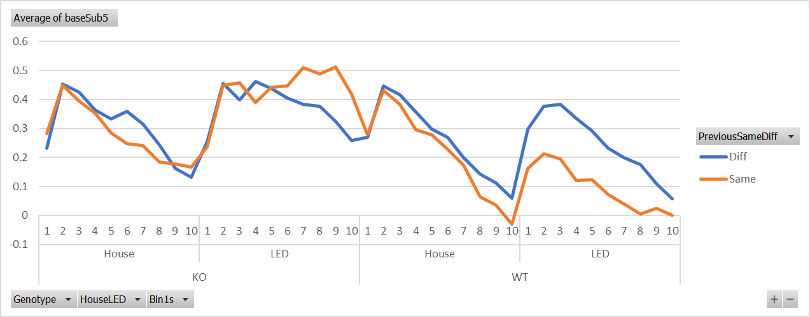
   2. Total Mouse/Session/Channels
      1. KO = 9
      2. WT = 16
   3. Missing data:

KO:

mouse45_20150515_session2_1

WT:

mouse23_20141009_session1_0

mouse35_20150223_session1_0

mouse35_20150223_session1_1

mouse48_20150518_session2_0

Post exclusions: KO N = 8, WT N = 12

Stats: Genotype*HouseLED*SameDiff*5sBin ANOVA

* No interactions
* WT LED 1st 5s, p = .04 Same vs Diff

1. Reward Exclusions 0 Pre 0 post; NaN exclusions 10 pre 10 post
   1. 1 mouse in KO is driving the LED response (due to reward delivery in Light Period)
   2. Missing data:

KO:

mouse45_20150515_session2_1

WT:

mouse35_20150223_session1_0

mouse35_20150223_session1_1

mouse48_20150518_session2_0

Post exclusions: KO N = 8, WT N = 12

Stats: Worse – Nothing Significant

1. Reward Exclusions 10 Pre 0 post; NaN exclusions 10 pre 10 post
   1. Exclusions

KO:

mouse45_20150515_session2_1

mouse40_20150505_session2_1

WT:

mouse19_20140416_session1_0

mouse35_20150223_session1_0

mouse35_20150223_session1_1

mouse44_20150518_session2_0

mouse48_20150518_session2_0

Post exclusions: KO N = 7, WT N = 11

Stats: pretty bad

1. Reward Exclusions 10 Pre 5 post; NaN exclusions 10 pre 10 post
2. Exclusions

KO:

mouse21_20141007_session1_0

mouse45_20150515_session2_1

mouse40_20150505_session2_1

WT:

mouse19_20140416_session1_0

mouse35_20150223_session1_0

mouse35_20150223_session1_1

mouse48_20150518_session2_0

Post exclusions: KO N = 6, WT N = 12

Stats: pretty bad

1. Reward Exclusions 10 Pre 10 post; NaN exclusions 10 pre 10 post
2. Exclusions

KO:

mouse21_20141007_session1_0

mouse45_20150515_session2_1

mouse40_20150505_session2_1

WT:

mouse19_20140416_session1_0

mouse35_20150223_session1_0

mouse35_20150223_session1_1

mouse48_20150518_session2_0

Post exclusions: KO N = 6, WT N = 12

Stats: pretty bad

Overall, one mouse is definitely throwing the WTs: mouse23_20141009_session1_0